Tab 1

**Swimlane Diagram:**

**Level 1.1:  
Name:** Registration & Login  
**Primary Actors:** User (Student, Teacher, Staff), Librarian  
**Secondary Actors:** OTP Generator, Email Generator

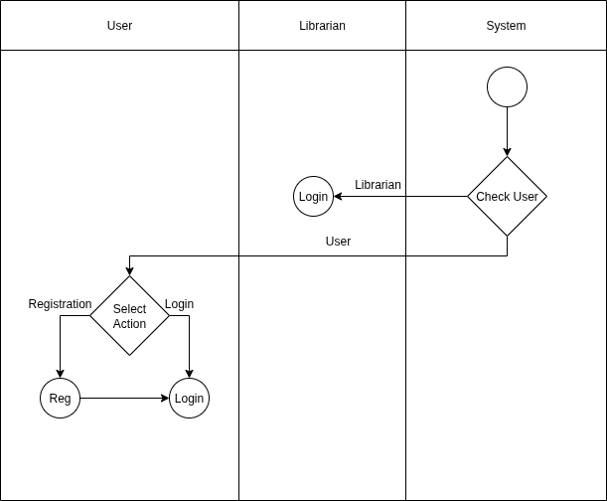

**Level 1.4:  
Name:** Borrow Book  
**Primary Actor:** User (Student, Teacher, Staff)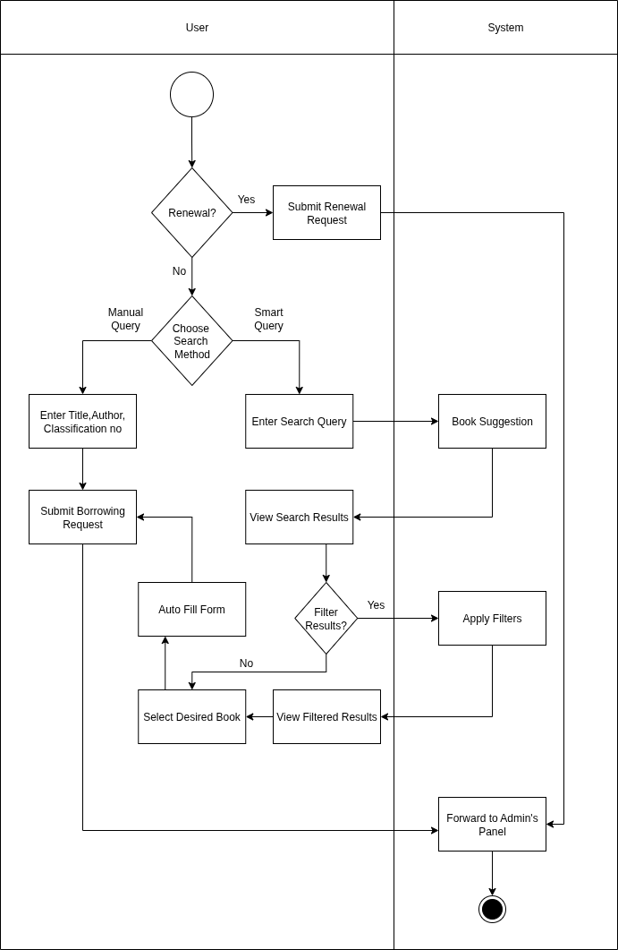

**Level:** 1.5.2  
**Name:** Eligibility   
**Primary Actor:** User (Student, Teacher, Staff), Librarian  
**Secondary Actor:** Email Generator, MFS

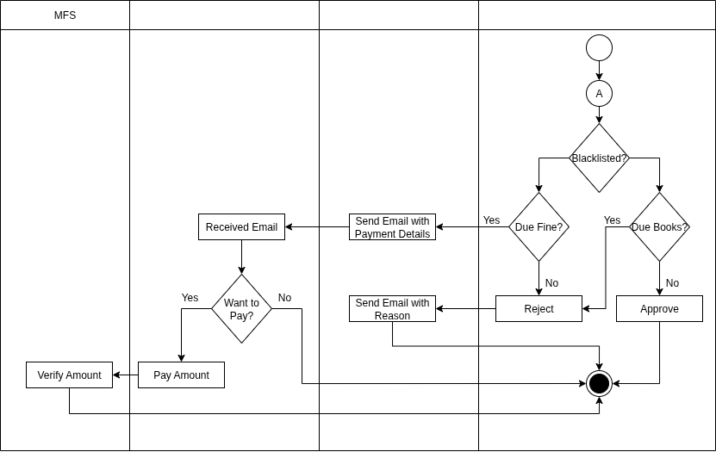

**Level 1.6:**  
**Name:** Clearance  
**Primary Actor:** User (Student, Teacher, Staff), Librarian  
**Secondary Actor:** Email Generator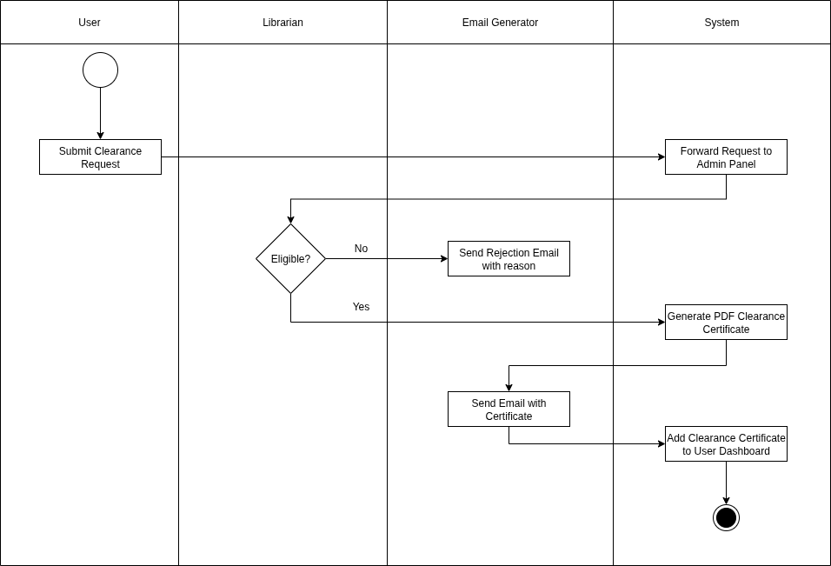

**Level:** 1.7  
**Name:** Update Book Record  
**Primary Actor:** Librarian, System  
**Secondary Actor:** BPC(Book Purchase Committee), Email Generator

